1.1 Project Overview

Executive summary: description of project, product summary

The idea of the website is simple. It is a platform that allows users to automate the shoe purchasing process. I will use a scraping tool to pull all relevant information for purchasing a shoe. After scraping the information the bot will proceed to purchase the shoes clicking on the appropriate buttons to execute the process. All the user will have to do is input their appropriate shoe size and the bot will take over from there! The intent of the website is to even the playing field of purchasing shoes online. As of today popular shoe releases are limited edition and people that have said sneaker bots tend to be the only ones who win out. The demand for shoes today far outway the supply and these sneakers take advantage of being able to automate the purchasing process and resell shoes at exuberant prices. This website will be an easy to use tool that will help everyday people to purchase shoes they like at a fair price via implementing one of the fastest scraping tools available (puppeteer) into a website.

Major Milestones include:

* Creation and maintenance of proper product documentation, including the SPMP, Gantt chart, WBS and use cases/requirements.
* React compatibility with API
* Project adaptability to conform to new challenges desired from users
* Puppeteer implementation

1.2 Project Deliverables (All items to be delivered, including delivery dates and location)

* Use Cases Document: October 15, 2020
* Software Project Management Plan: October 20, 2020
* Project Requirements Document: October 20, 2020
* Gantt Chart: October 20, 2020
* Product Front-End and Back-End Initialization: November 25, 2020
* Testing Skeleton: November 20, 2020
  + Unit test
  + Regression testing
  + System test
* Components: November 20, 2020
  + Home
  + Input for users
* Deployment: November 30, 2020

1.3 Evolution of the SPMP

In designing my used cases I realize there are many things that can be added to improve the functionality. The use cases I have established are meant to be applicable to the scope. I appreciate the functionality of my website and what it offers but I would like to put more effort into the website's UI if time permits. In the future I could look into updating the website with links to the major limited edition shoe releases so the user does not have to grab the url. I would also look into hosting a blogging site to foster a sense of community amongst novice sneaker botters.

1.4 Reference Materials

Complete list of materials referenced in SPMP

Repository: <https://github.com/sjohns98/Puppetter>

SPMP template:<http://users.csc.calpoly.edu/~jdalbey/205/Mgmt/SPMP>

Web framework: MERN stack

Gantt chart software:

Puppeteer Documentation: <https://github.com/puppeteer/puppeteer>

Sneaker Bot referenced: <https://github.com/tylerburleigh/nike-buy-bot>

1.5 Definitions and Acronyms

* MERN - MongoDB, Express.js, React, Node.js
* Puppeteer - Node library that provides high level API for interacting with websites.

**2. Project Organization**

2.1 Process Model

Relationships among project elements:

The relationship between project elements is demonstrated in the following. I will use the spiral model to organize the workflow process. This model gives consistent prototype development and risk analysis so that expectations are maintained throughout the project.

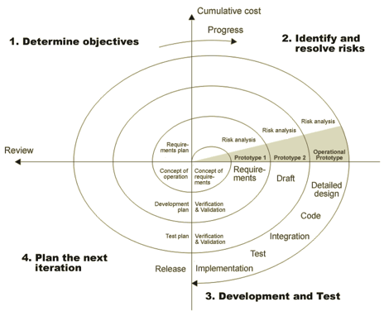

2.3 Organizational Interfaces

Relations with other entities (subcontractors, commercial software)

**3. Managerial Process**

3.2 Assumptions, Dependencies and Constraints

External events the project depends on, constraints under which the project is to be conducted

Constraint: The project must have a working prototype by early December that showcases basic functionality.

Contingency: Organize consistent development meetings and regularly update task scheduling. This will help ensure deadlines are met.

Constraint: The general purpose of the project is to enable people to purchase shoes they want.

Contingency: Project will have to be maintained so that it is competitive with other bots and evolves with the security of sneaker websites.

Constraint: There is no budget or expectation of funding.

Contingency: All development will require using open-source software for implementation.

3.3 Risk Management :

Breakdown of risk factors:

* Insufficient time to test product before deadline
* Website not being efficient enough to warrant people to want to use it
* Security update preventing the use of the bot
* Misuse of the bot causing users to get banned

At this time the risk factors do not exceed likelihood of success with the project. These factors are best prevented by providing myself enough time and by updating botting features to keep in line with current security measures.

3.5 Monitoring and Controlling Mechanisms

Frequency and mechanisms for reporting:

I will maintain a project log that will be key for documentation and progress monitoring. The project log will assist me in evaluating my progress and tracking key decisions made.

**Selected Software Process:**

* MERN - MongoDB, Express.js, React, Node.js, Puppeteer API

**4. Technical Process**

**4.1 Methods, Tools, and Techniques - Specific technical methods used.**

The application is designed primarily for web use therefore the website will be available on all common browsers. However the usage of the API will require either Chrome or Chromium. Code will be written in JS using Node.js and UI framework Bootstrap for React. Backend served written in Node.js using express. Database will be MongoDB. Unit testing will be done with Jest. Hosting on Heroku and deployment through Travis.

**4.2.3 Software Test Plan**

Template: <https://xbosoft.com/website-testing/web-application-testing-services/?gclid=EAIaIQobChMItO7t-6-K7AIViYzICh1ARgzOEAAYASACEgIyh_D_BwE>

Scheduling:

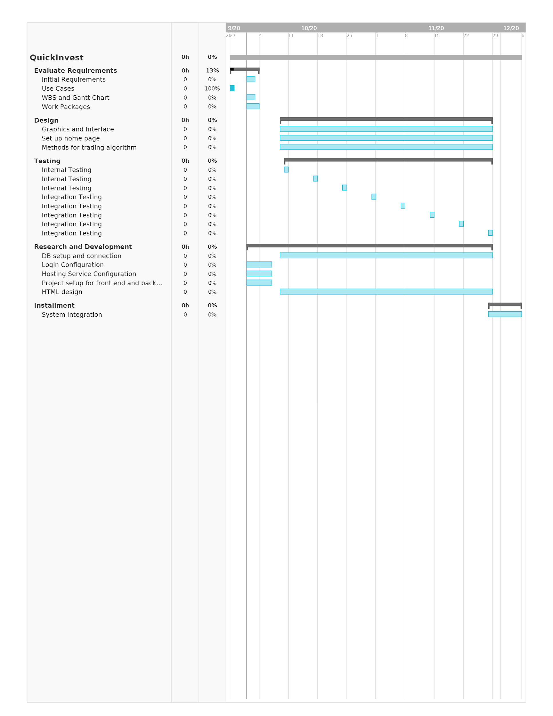

**6.** **Additional Components**

In the future other components will be added to the SPMP as needed. Such as management plans if a team becomes involved or security plans to ensure my algorithm is not stolen by another developer.